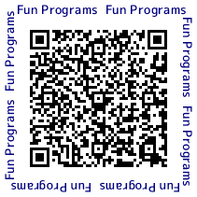

**A Special Early Summer Edition**

**(Hospitality)Newsletter**

**The Citizens’ *Omotenashi***

Scan code

to experience

**The 9th Edition**

Toyota City’s

warm hospitality!

by Carl Taffe

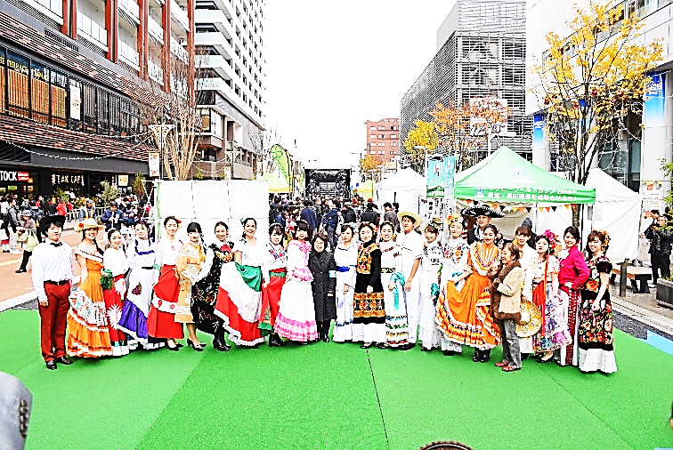

**Volunteers Urgently Needed!!! Apply Now!!!**

●Target: Individuals who can communicate in either English, Italian, Samoan, Georgian, etc., attend orientations & lectures, and be available to work during the major rugby tournament approaching

●Period: September 14 (Saturday) to October 20 (Sunday), 2019

●Tasks: ① Give guidance at information booths at Toyota-shi Station

② Give information and interpretation on Japanese

Culture at Toyota-shi Station and surrounding areas

③ Distribute multilingual pamphlets, etc. at Toyota-shi Station

and surrounding areas

●Orientation/Meeting

1st June 30 (Sunday) 10:00 am to noon

2nd August 31 (Saturday) 1:00 pm to 3:00 pm

●Limit: 30 people, or as many as are needed

●Charge: Free

●Application: Complete the application form on the reverse-side of this newsletter and submit it via E-mail, or FAX to TIA by June 25!



**Join the Toyota Oiden Festival Parade on Stage!**

Brace yourselves for another thrilling installment of the Toyota City Oiden Parade and Dance Festival. What is absolutely unique about this year’s festival is that the Toyota City Global Citizens Conference (TCGCC), in collaboration with the Toyota City International Association (TIA), have paved the way for interested foreign residents living in and around the area to parade on the stage. This is an exciting opportunity worth trying.

The dance festival takes place on the last weekend of July, usually on the Saturday evening, which falls on July 27 this year. The event is annually accompanied by firework attractions the following day. You are summoned among thousands of other revelers who take to the streets of downtown Toyota City for this spectacle each year. Seize the opportunity to enjoy the sights, the delectable food, or the irresistible urge to get on the dance floor of the crowded city streets of Toyota City and dance up a storm.

Foreign nationals wishing to join the parade must submit details including their name, country, and contact information to TIA, or the TCGCC by July 12, 2019. Foreigners with the means will be invited to parade in a traditional attire representative of their home country. For more details, please contact TIA, or TCGCC via Email.

**When:** On July 27, preceding the dance finals. **Where:** Smack in the middle of Downtown Toyota. **Time:** 5:30 pm to 7:00 pm. **Meeting Place:** TIA, which is located on the 3rd floor of the Culture and Industry Center (1-25 Kozakahon-machi, Toyota City, Aichi Prefecture, 471-0034). **Contact:** Send an Email to: tia@hm.aitai.ne.jp, or to: toyotashiminkaigi@gmail.com, and include your name, nationality, and contact details including a number where you can easily be reached. To apply as a group, the name of each individual member is required when you submit your Email.

**When:** Volunteers will be invited to work on specific days between September 14 and October 20, 2019, primarily on the days of the rugby games. The work schedule will be on a shift basis and will be announced in a timely manner. Individuals would only be required to work for a few hours at most on a given day, depending on their availability. Orientation is on Sunday, June 30 (from 10:00 am), and Saturday, August 31 (from 1:00 pm). **Time**: Shifts between 10:00 am and 10:00 pm, to be announced in a timely manner. **Charge**: Free.

**Contact**: Submit your application by email to: **tia@hm.aitai.ne.jp**, or fax it in to: **0565-33-5950**. *The deadline to apply is **Tuesday, June 25, 2019**. Please contact TIA at **0565-33-5931** with all your enquiries.

**TIA marks October 1st as ‘International Day’ in Toyota City annually. TIA: [Tel: 0565-33-5931 Fax: 0565-33-5950 Email: tia@hm.aitai.ne.jp]**

**\*International Day is a day we assemble to celebrate mutual understanding, cultural diversity, and exchange friendships in Toyota City.**

**Multilingual Volunteer Application Form**

|  |  |  |  |
| --- | --- | --- | --- |
|  | | | 受付Ｎｏ.（事務局記入欄） |
| ①Name: | （Name in katakana ） | | |
|  | | |
| ②Address: | In Toyota City　　・　　Outside of Toyota | | |
| ③Contact Info | Tel: (where you can most easily be reached) |  | |
| Email: |  | |
| ④Spoken Languages  & Level | Spoken Languages:  ※Circle the level which applies in your case:  Conversational　・　Business　・　Fluent　・　Native (equivalent) | | |
| ⑤Available Date(s) and Time(s) |  | | |
| ⑥Other |  | | |

※The information you share will not be used for any other reason than the purposes stipulated.

【事務局（ＴＩＡ）記入欄】

|  |  |  |  |  |  |  |
| --- | --- | --- | --- | --- | --- | --- |
| 上記の人材を、「緊急多言語ガイドボランティア」に正式に登録します。 | | | | | | |
| 受付日  　　年　　月　　日 | 決定日  年　　　月　　日 | 決定者 | 検討者 | | | 受付者 |
|  |  |  |  |  |
| ボランティア登録Ｎｏ． | |